Loh Sze Kye (S10257172) – IT05

DP Assignment 2 Final – PDF Document

Table of Contents

**Wireframes** 1

**Screenshots of prototype** 11

**Features** 16

**New features** 16

**Revamped features** 16

**References:** 17

# **Wireframes**

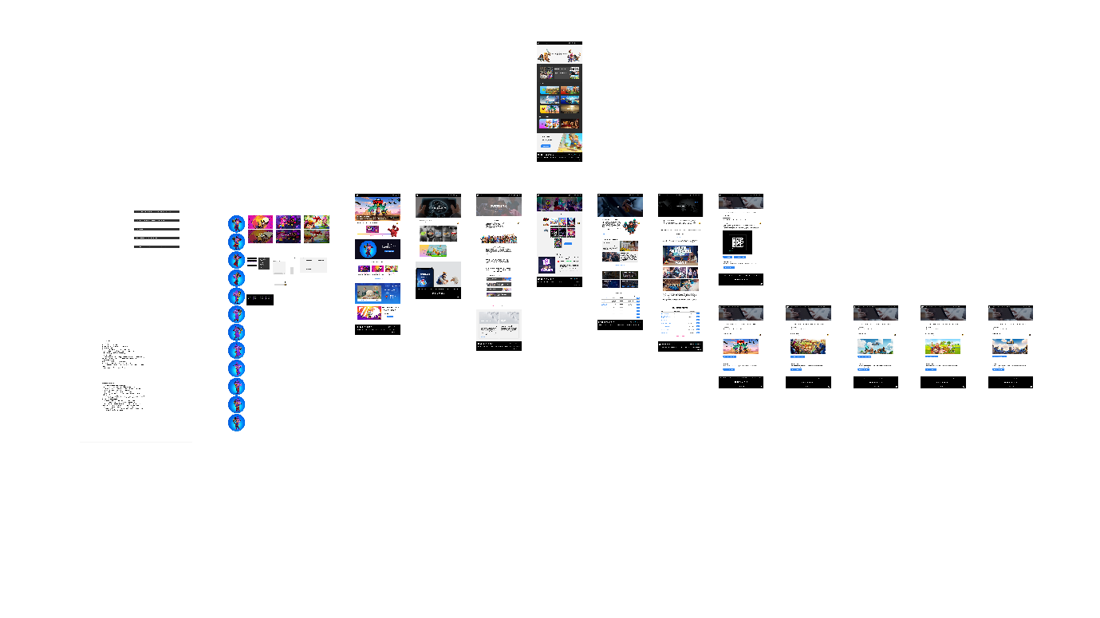

High fidelity wireframe

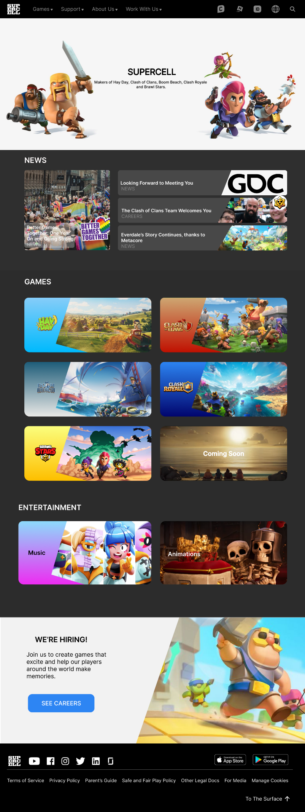 Home high fidelity wireframe

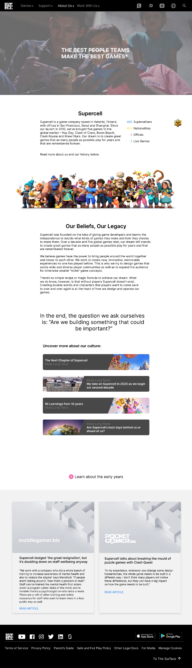 About us high fidelity wireframe

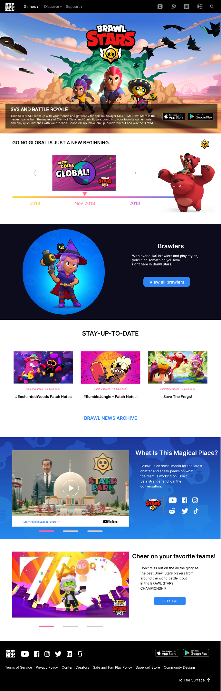 Game 1(Brawl Stars) high fidelity wireframe

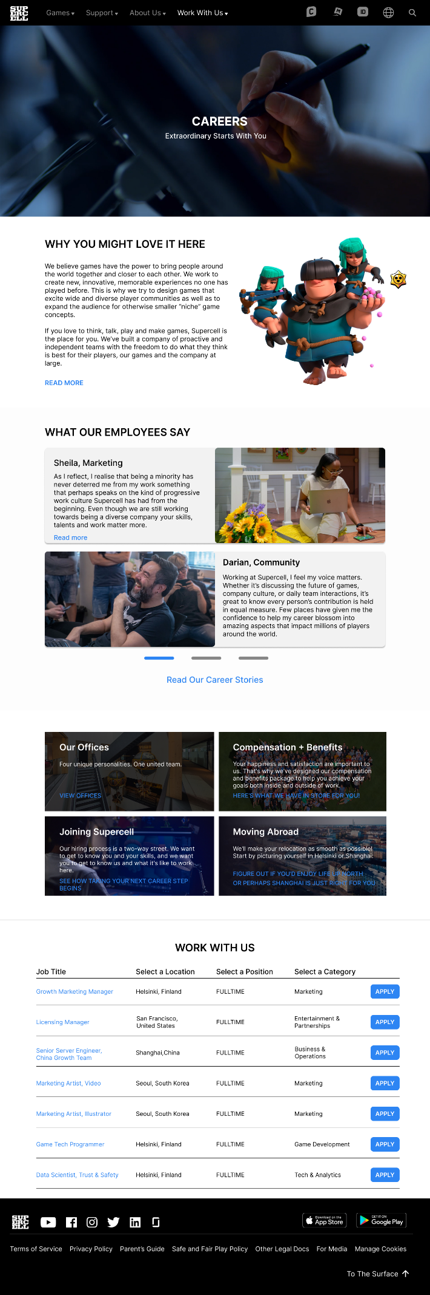 Careers high fidelity wireframe

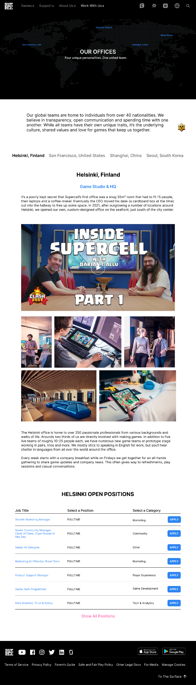 Our offices high fidelity wireframe

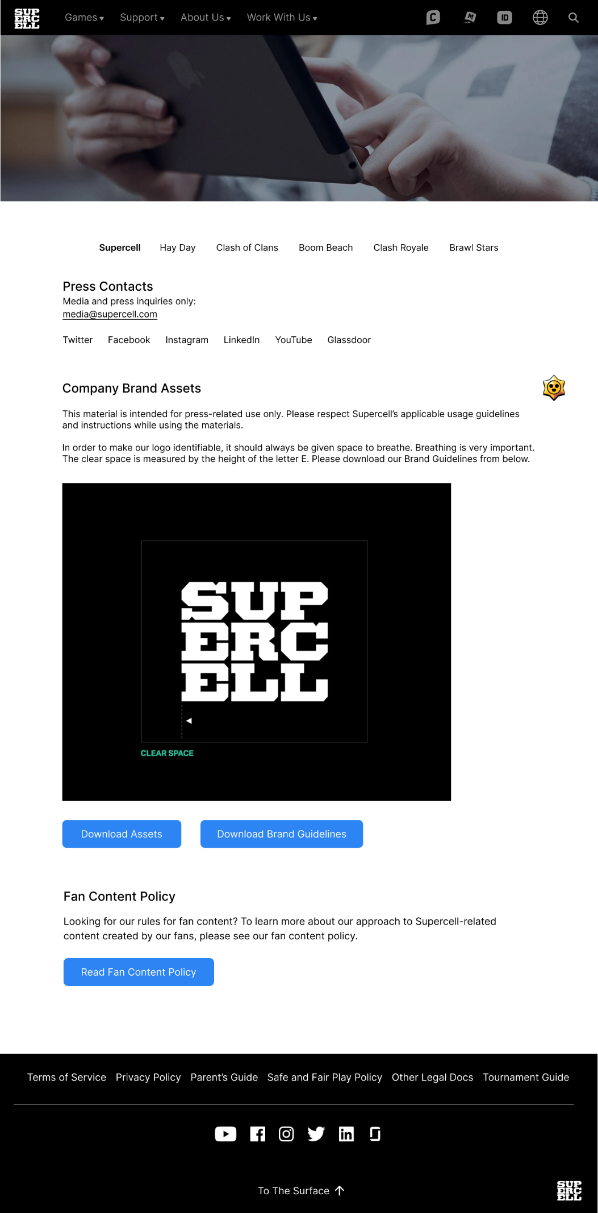

For media (Supercell) high fidelity wireframe

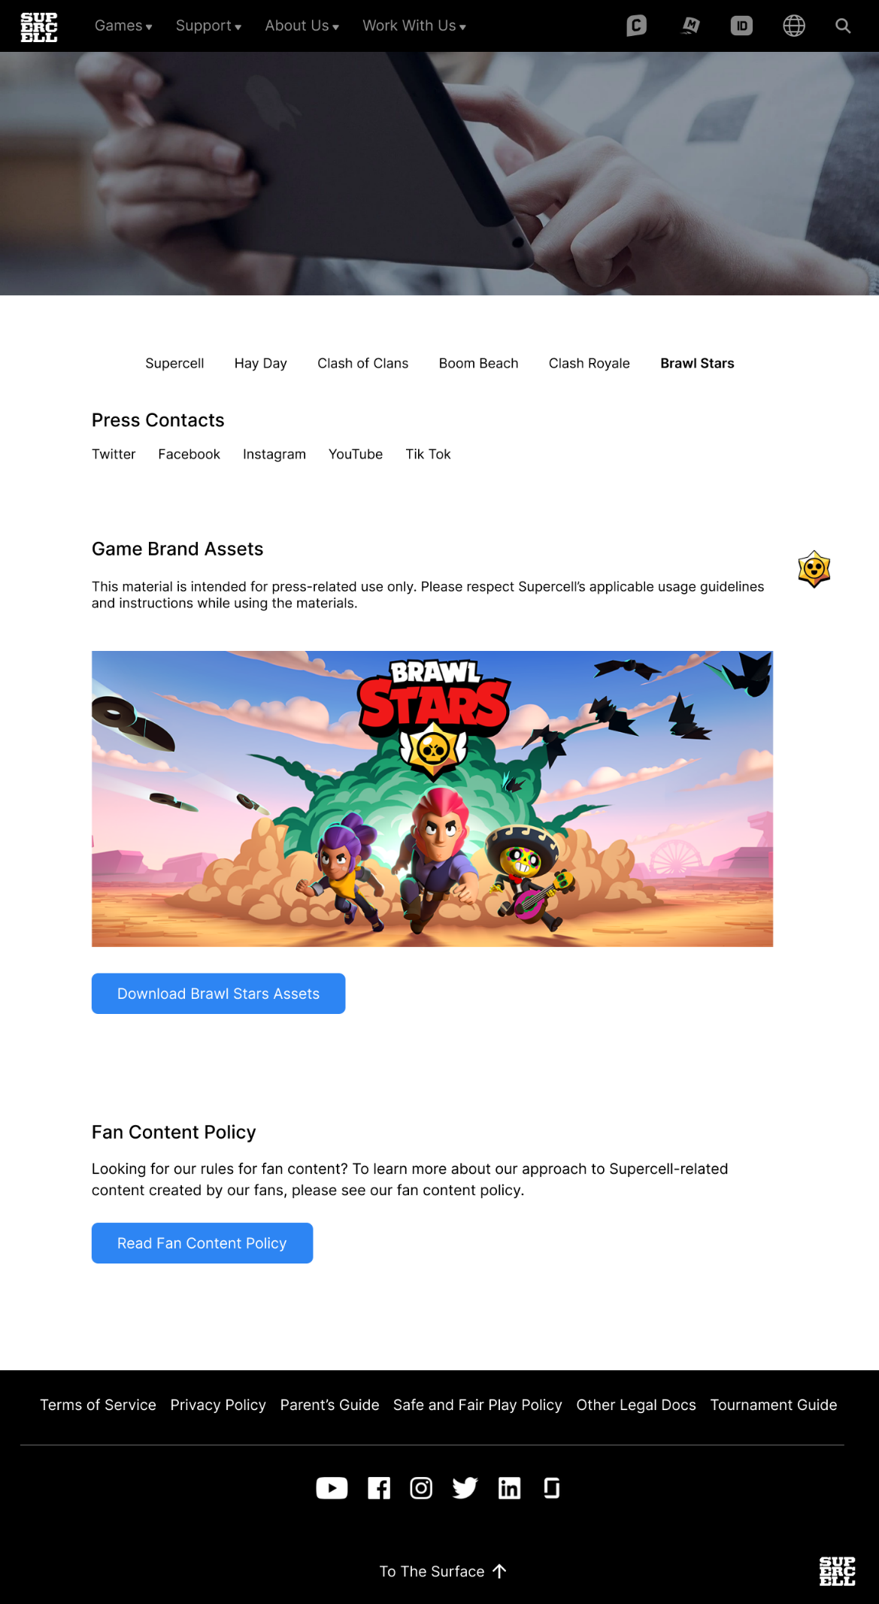

For media (Game 1(Brawl Stars)) high fidelity wireframe.

# **Screenshots of prototype**

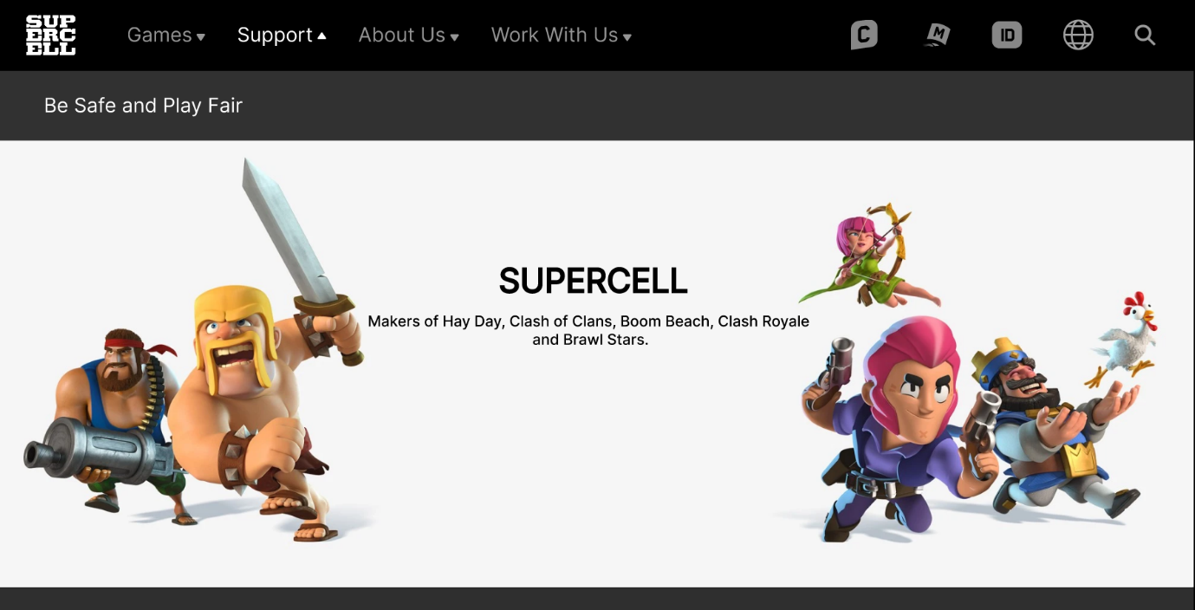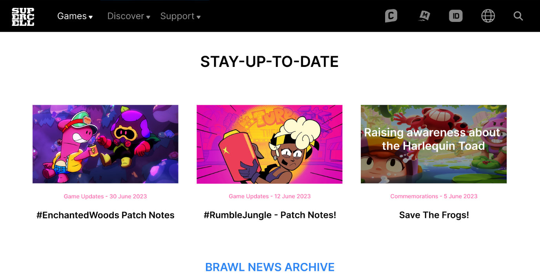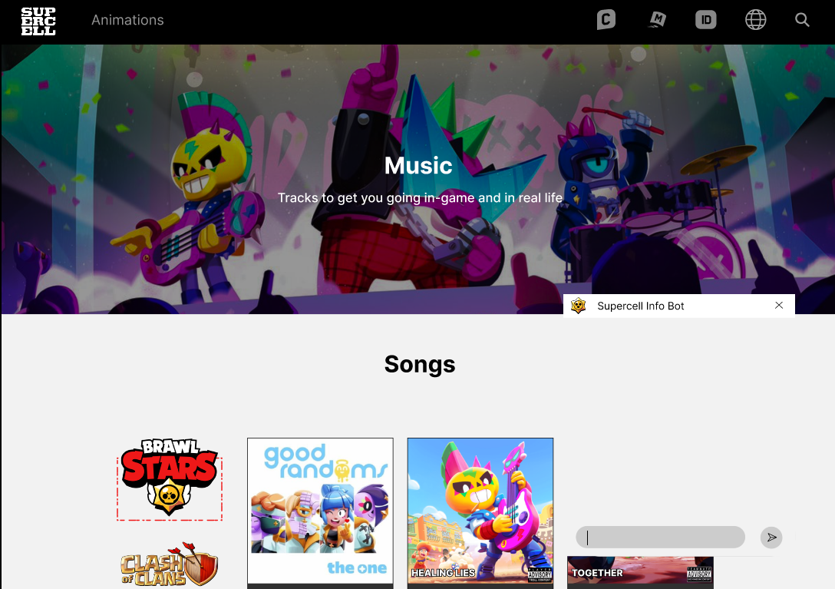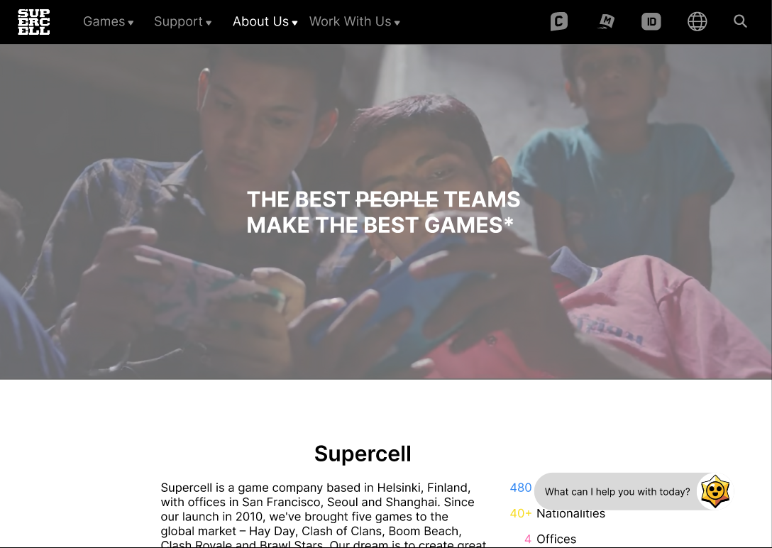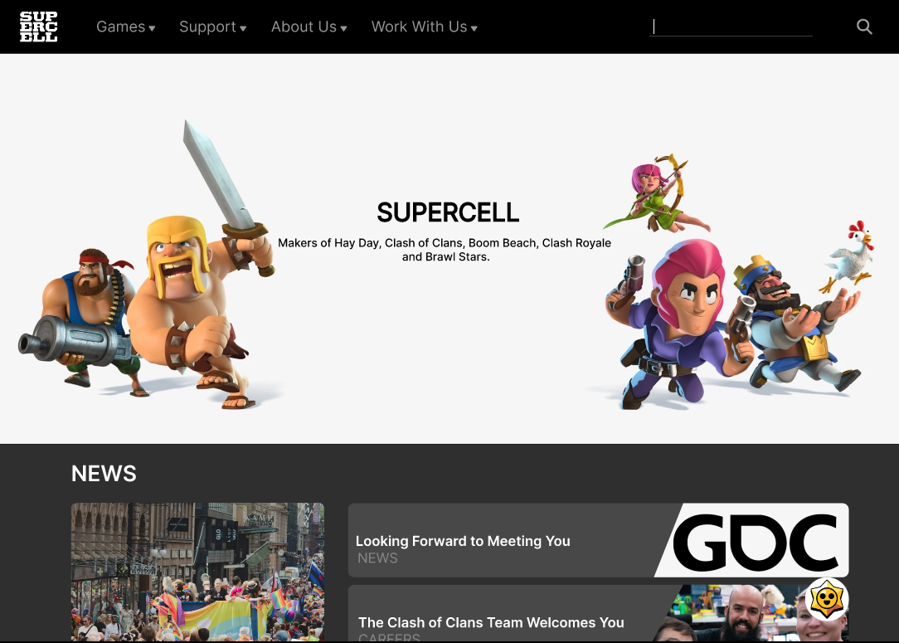

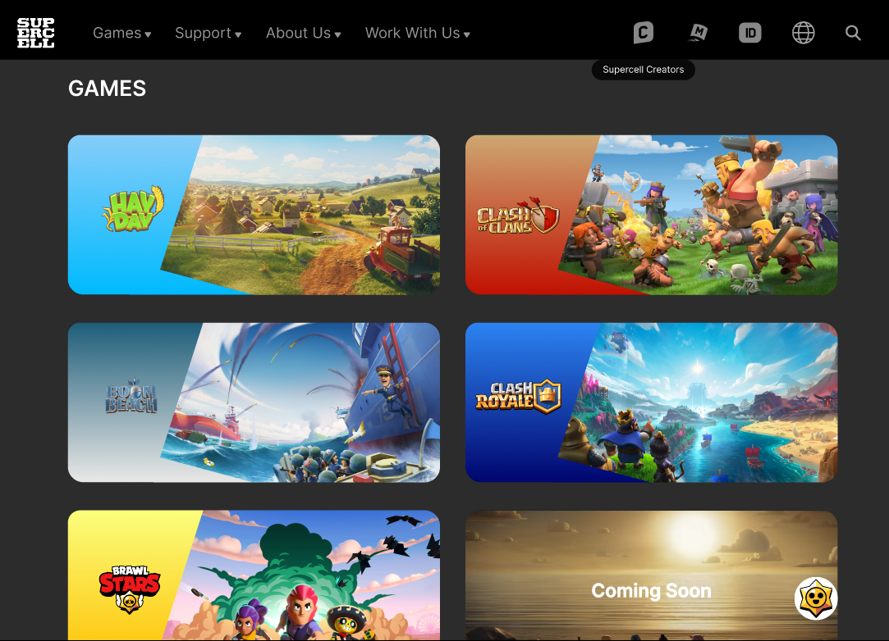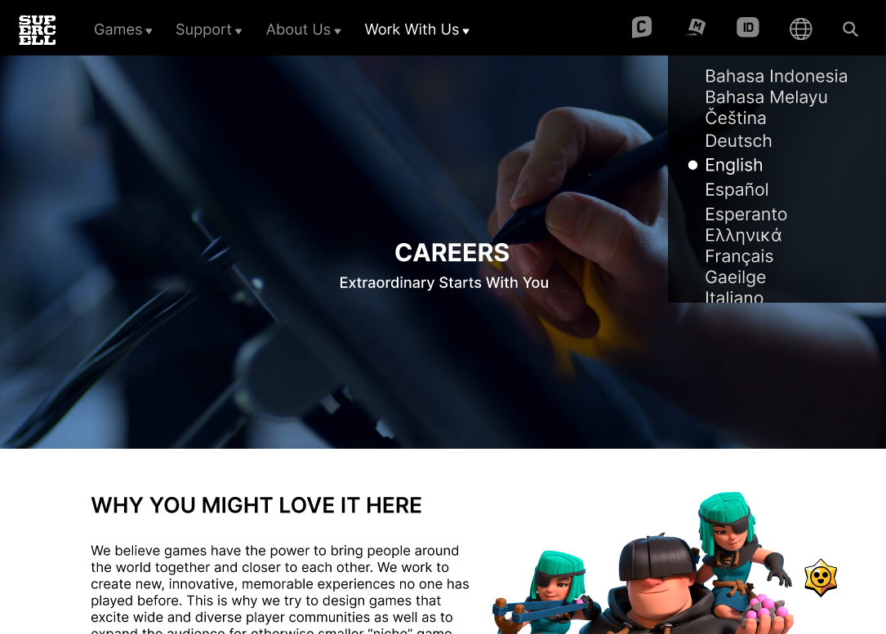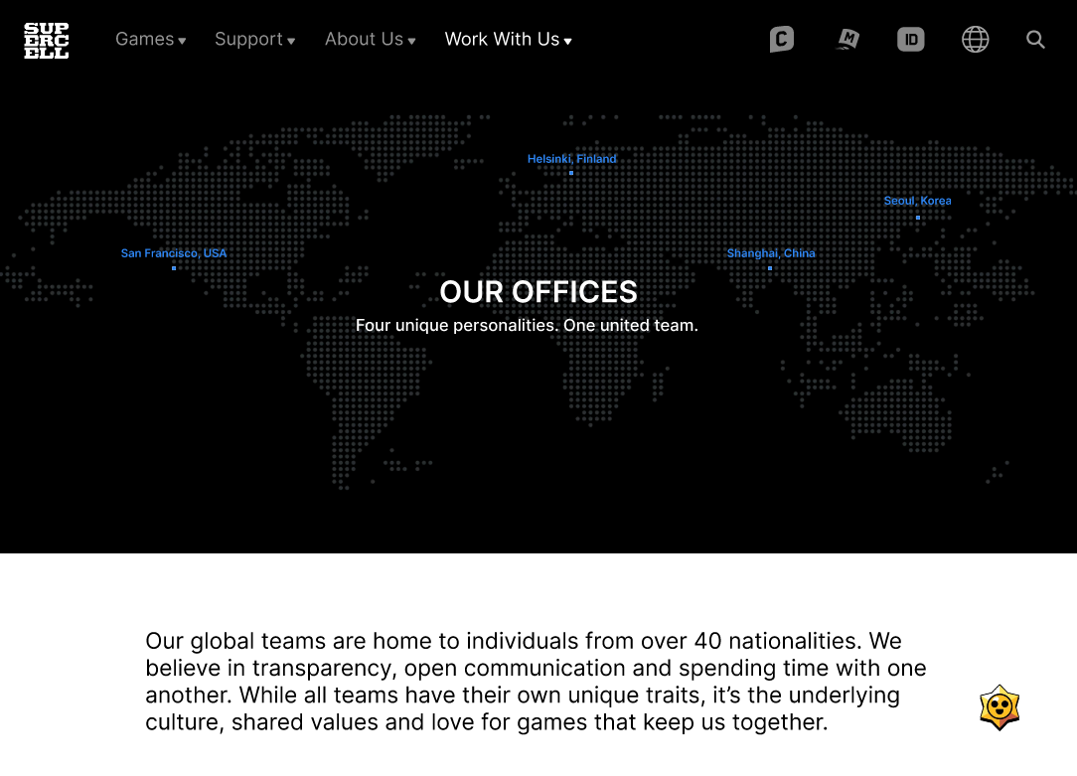

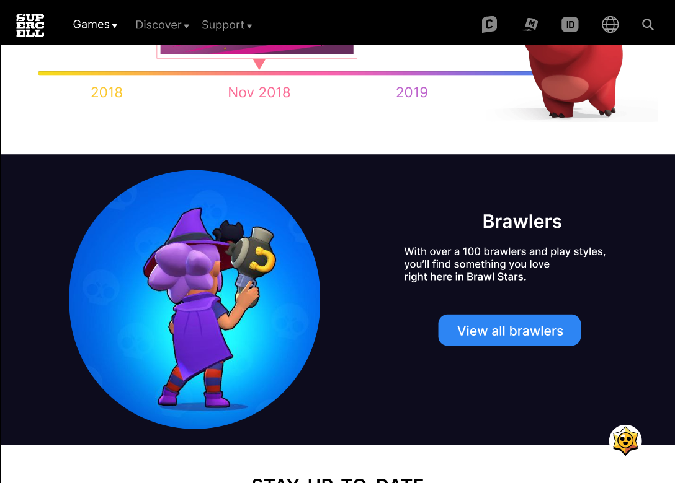

# **Features**

## **New features**

* Added a chatbot.
* Added the option to change language.
* Added an entertainment section on the homepage. This is to publicise the fact that Supercell also creates music and produces animations.
* New music webpage. This webpage contains all the songs and podcasts that have been released.
* Added a brawlers section on the Game 1’s (Brawl Stars) page – with a rotating brawler to show what an in-game character looks like.
* Esports section on the Brawl Stars page. This lets new visitors know that Brawl Stars
* has its own esports and provides improved accessibility.
* Zoom in ability when hovering over the news images on the Brawl Stars page.
* Name displays when hovering over the Supercell ID, Supercell Make, and Supercell
* Creators’ icon. (The 3 grey icons starting from the left in all the headers.) This is so as
* to give new visitors a better idea of what it is.
* Added a To The Surface button in the footer for convenience.
* New drop down menu called discover on the each of the games’ page for more webpages pertaining to the game (current game being used as an example would be Brawl Stars).
* Downward pointing triangle to indicate the presence of a drop-down menu (quality of life improvement).
* Going global section on the Brawl Stars page to show how far the game has come.

## **Revamped features**

* Refreshed games section on the homepage.
* Refreshed the hero section of the Our Offices page.
* Refreshed the image, text, and navigation layouts of the Our Offices page.
* Refreshed the what our employees have to say section on the About Us page.
* Refreshed the statistics and image layout on the About Us page.
* Refreshed the support section layout on the Support page. Each section of the image will take the visitor to their respective support pages.
* Refreshed the follow us section on the Game 1’s page. (Title: What is this   
  magical place?)
* Changed the layouts of the For Media (Supercell), For Media (Game 1),  
  For Media (Game 2), For Media (Game 3), For Media (Game 4),   
  For Media (Game 5) pages.
* Refreshed the news section layout on the homepage.
* Slight changes to the footers of For Media (Supercell),   
  For Media (Game 1), For Media (Game 2), For Media (Game 3), For   
  Media (Game 4), For Media (Game 5), Support and Brawl Stars page.
* Refreshed the hero section layout of Game 1’s page.
* Refreshed the layout of the we are hiring section on the homepage.
* Refreshed the layout of the games section on the homepage.

# **References:**

*About Us × Supercell*. (n.d.). Supercell. Retrieved June 27, 2023, from https://supercell.com/en/about-us/

*Supercell*. (n.d.-c). Supercell. Retrieved July 25, 2023, from https://supercell.com/en/

*Brawl Stars × Supercell*. (n.d.). Supercell. Retrieved July 25, 2023, from https://supercell.com/en/games/brawlstars/

*Support × Supercell*. (n.d.). Supercell. Retrieved July 25, 2023, from https://supercell.com/en/support/

*For Media × Supercell*. (n.d.-b). Supercell. Retrieved July 25, 2023, from https://supercell.com/en/for-media/

*Our offices × Supercell*. (n.d.). Supercell. Retrieved July 25, 2023, from https://supercell.com/en/careers/our-offices/

*Careers × Supercell*. (n.d.-b). Supercell. Retrieved July 25, 2023, from https://supercell.com/en/careers/

*Career stories × Supercell*. (n.d.). Retrieved July 25, 2023, from https://supercell.com/en/career-stories/

Long, N. (2022). Supercell dodged ‘the great resignation’, but it’s doubling down on staff wellbeing anyway. *Mobilegamer.biz*. https://mobilegamer.biz/supercell-dodged-the-great-resignation-but-its-doubling-down-on-staff-wellbeing-anyway/

Astle, A. (2022, February 15). *Supercell talks breaking the mould of puzzle games with Clash Quest*. pocketgamer.biz. Retrieved July 25, 2023, from https://www.pocketgamer.biz/interview/78151/making-of-clash-quest/

*Media Kit Archive — Spotify*. (n.d.). Spotify. https://newsroom.spotify.com/media-kit/

*YouTube Brand Resources and Guidelines - How YouTube Works*. (n.d.). YouTube Brand Resources and Guidelines - How YouTube Works. https://www.youtube.com/howyoutubeworks/resources/brand-resources/#logos-icons-and-colors

*File:Apple Music logo.svg - Wikimedia Commons*. (2015). https://commons.wikimedia.org/wiki/File:Apple_Music_logo.svg

https://i.ytimg.com/vi/geBtyZP2qIM/maxresdefault.jpg

https://i.ytimg.com/vi/XG1NI--CLfk/maxresdefault.jpg

*Brawl Stars: GLOBAL LAUNCH!* (2018, November 14). YouTube. Retrieved August 11, 2023, from https://www.google.com/url?sa=i&url=https%3A%2F%2Fwww.youtube.com%2Fwatch%3Fv%3DgeBtyZP2qIM&psig=AOvVaw1vvQrb5uvaAOE5VAXOxSOU&ust=1691832550344000&source=images&cd=vfe&opi=89978449&ved=0CBEQjRxqFwoTCJippMOl1IADFQAAAAAdAAAAABAE

*Supercell: for everyone*. (2020, October 26). YouTube. Retrieved August 11, 2023, from https://www.google.com/url?sa=i&url=https%3A%2F%2Fwww.youtube.com%2Fwatch%3Fv%3DXG1NI--CLfk&psig=AOvVaw0EgSwsFhTssyOWFLFFTiPw&ust=1691832496817000&source=images&cd=vfe&opi=89978449&ved=0CBEQjRxqFwoTCMDd-Kml1IADFQAAAAAdAAAAABAE

https://storage.buzzsprout.com/variants/ov024v4kit7z0rek5d7etjwitk6x/60854458c4d1acdf4e1c2f79c4137142d85d78e379bdafbd69bd34c85f5819ad.jpg

*Time to Explain - The Brawl Stars Podcast*. (n.d.). Buzzsprout. https://www.buzzsprout.com/2163546

https://i.ytimg.com/vi/pVeF5m1Q9Pc/hq720.jpg?sqp=-oaymwE7CK4FEIIDSFryq4qpAy0IARUAAAAAGAElAADIQj0AgKJD8AEB-AH-CYAC0AWKAgwIABABGH8gHSg6MA8=&rs=AOn4CLDGwciOOJS2z_EqFCm6GoTKeLuVg

*Rise up to the top (Extended version)*. (n.d.). YouTube. https://www.google.com/url?sa=i&url=https%3A%2F%2Fwww.youtube.com%2Fwatch%3Fv%3DY0acUZLknK4&psig=AOvVaw3EIfW_JtHaXA_VgH-lu6FW&ust=1691832888397000&source=images&cd=vfe&opi=89978449&ved=0CBEQjRxqFwoTCJCsp-Sm1IADFQAAAAAdAAAAABAE

https://i.scdn.co/image/ab67616d0000b2736dc67a51a2b49d348c33e81c

*Brawl Stars & Good Randoms – The One*. (2023, April 1). Genius. https://genius.com/Brawl-stars-and-good-randoms-the-one-lyrics

https://i.scdn.co/image/ab67616d0000b273f06313da3c4da3f7c1f2db9c

*Brawl Stars & Bad Randoms – together*. (2022, January 13). Genius. Retrieved August 11, 2023, from https://genius.com/Brawl-stars-and-bad-randoms-together-lyrics

*Brawl Stars & Bad Randoms – Healing Lies*. (2022, January 21). Genius. Retrieved August 11, 2023, from https://genius.com/Brawl-stars-and-bad-randoms-healing-lies-lyrics

*THE NEXT CHAPTER OF SUPERCELL*. (2023, February 15). Supercell. Retrieved August 11, 2023, from https://supercell.com/en/news/next-chapter/

*Are our best days behind us or ahead of us?* (2022, February 15). Supercell. Retrieved August 11, 2023, from https://supercell.com/en/news/best-days/

*My Take on Supercell in 2020 as We Begin Our Second Decade*. (2021, February 16). Supercell. Retrieved August 11, 2023, from https://supercell.com/en/news/my-take-supercell-2020-we-begin-our-second-decade/

*Are Our Best Days Behind Us or Ahead of Us?* (2022, February 15). Supercell. Retrieved August 11, 2023, from https://supercell.com/en/news/best-days/

*10 Learning from 10 Years*. (2020, May 14). Supercell. Retrieved August 11, 2023, from https://supercell.com/en/news/10-learnings-10-years/

https://i.ytimg.com/vi/3fLxSw42RZk/maxresdefault.jpg

*Clash Fest: Inside Supercell Part 1*. (2022, September 6). YouTube. Retrieved August 11, 2023, from https://www.google.com/url?sa=i&url=https%3A%2F%2Fwww.youtube.com%2Fwatch%3Fv%3D3fLxSw42RZk&psig=AOvVaw3l3a2cwdFOPsUkxXfa2nk0&ust=1691834245460000&source=images&cd=vfe&opi=89978449&ved=0CBEQjRxqFwoTCMDg9eur1IADFQAAAAAdAAAAABAJ

*Our legal documents × Supercell*. (n.d.). Supercell. https://supercell.com/en/our-legal-documents/